24SDCS02 / 24SDCS02E / 24SDCS02P / 24SDCS02L – FSAD WORKBOOK
DEPARTMENT OF CSE, CS&IT, AI&DS
COURSE CODE: 24SDCS02 / 24SDCS02E / 24SDCS02P / 24SDCS02L
FULL STACK APPLICATION DEVELOPMENT Date of the Session: / / Time of The Session: to #SKILL - 3 ⎝ Working with HQL - Sorting, Pagination & Aggregates
Prerequisites:
• Basic knowledge of Hibernate
• Basic idea of HQL syntax
In this lab, you will extend the Hibernate module created in Skill 2 and perform advanced data retrieval using HQL, including sorting, pagination, filtering, and aggregate functions. These operations help in retrieving structured and meaningful data from the database using Hibernate.
Tasks: 1. Use the Product entity created in Skill 2.
2. Add 5–8 additional Product records into the database.
3. Write HQL queries to retrieve all products sorted by price:
a. Ascending order
b. Descending order
4. Write an HQL query to sort products by quantity (highest first).
5. Implement pagination using HQL to display:
a. First 3 products
b. Next 3 products
6. Write HQL queries for aggregate operations:
a. Count total number of products
b. Count products where quantity > 0
c. Count products grouped by description
d. Find minimum and maximum price
7. Write an HQL query using GROUP BY to group products by description.
8. Write an HQL query using WHERE to filter products within a price range.
9. Write HQL queries using LIKE such as:
a. Names starting with certain letters
b. Names ending with certain letters
c. Names containing a pattern anywhere (substring)
d. Names with an exact character length 10. Push the Hibernate project to GitHub.
Product.java
package com.entity;

import javax.persistence.*;

@Entity
@Table(name = "products")
public class Product {

@Id
@GeneratedValue(strategy = GenerationType.IDENTITY)
private int id;

private String name;
private String description;
private double price;
private int quantity;

public Product() {}

public Product(String name, String description, double price, int quantity) {
this.name = name;
this.description = description;
this.price = price;
this.quantity = quantity;
}
}
HQLOperations.java
package com.main;
import java.util.List;
import org.hibernate.Session;
import org.hibernate.query.Query;
import com.entity.Product;
import com.util.HibernateUtil;
public class HQLOperations {
public static void main(String[] args) {
Session session = HibernateUtil.getSessionFactory().openSession();
Query<Product> q1 = session.createQuery(
"FROM Product p ORDER BY p.price ASC", Product.class);
List<Product> list1 = q1.list();
Query<Product> q2 = session.createQuery(
"FROM Product p ORDER BY p.price DESC", Product.class);
Query<Product> q3 = session.createQuery(
"FROM Product p ORDER BY p.quantity DESC", Product.class);
Query<Product> q4 = session.createQuery("FROM Product", Product.class);
q4.setFirstResult(0);
q4.setMaxResults(3);

Long total = session.createQuery(
"SELECT COUNT(p) FROM Product p", Long.class)
.uniqueResult();

Object[] minMax = session.createQuery(
"SELECT MIN(p.price), MAX(p.price) FROM Product p",
Object[].class).uniqueResult();

Query<Product> q5 = session.createQuery(
"FROM Product p WHERE p.price BETWEEN :min AND :max",
Product.class);
q5.setParameter("min", 500);
q5.setParameter("max", 10000);

session.close();
}
}
InsertData.java
package com.main;

import org.hibernate.Session;
import org.hibernate.Transaction;
import com.entity.Product;
import com.util.HibernateUtil;

public class InsertData {

public static void main(String[] args) {

Session session = HibernateUtil.getSessionFactory().openSession();
Transaction tx = session.beginTransaction();

session.save(new Product("Laptop", "Electronics", 55000, 10));
session.save(new Product("Mouse", "Electronics", 500, 50));
session.save(new Product("Keyboard", "Electronics", 1200, 30));
session.save(new Product("Chair", "Furniture", 3500, 15));
session.save(new Product("Table", "Furniture", 7000, 5));
session.save(new Product("Bottle", "Accessories", 300, 100));
session.save(new Product("Notebook", "Stationery", 80, 200));

tx.commit();
session.close();

System.out.println("Data Inserted Successfully!");
}
}
HibernateUtil.java
package com.util;

import org.hibernate.SessionFactory;
import org.hibernate.cfg.Configuration;

public class HibernateUtil {

private static final SessionFactory factory =
new Configuration().configure().buildSessionFactory();

public static SessionFactory getSessionFactory() {
return factory;
}
}
Hibernate.cfg.xml
<?xml version="1.0" encoding="UTF-8"?>
<!DOCTYPE hibernate-configuration PUBLIC
"-//Hibernate/Hibernate Configuration DTD 3.0//EN"
"http://hibernate.sourceforge.net/hibernate-configuration-3.0.dtd">

<hibernate-configuration>
<session-factory>

<property name="hibernate.connection.driver_class">
com.mysql.cj.jdbc.Driver
</property>

<property name="hibernate.connection.url">
jdbc:mysql://localhost:3306/hibernate_db
</property>

<property name="hibernate.connection.username">root</property>
<property name="hibernate.connection.password">akshayaumesh20</property>

<property name="hibernate.dialect">
org.hibernate.dialect.MySQL8Dialect
</property>

<property name="hibernate.hbm2ddl.auto">update</property>

<property name="hibernate.show_sql">true</property>

<mapping class="com.entity.Product"/>

</session-factory>
</hibernate-configuration>
Pom.xml
<project xmlns="http://maven.apache.org/POM/4.0.0"
xmlns:xsi="http://www.w3.org/2001/XMLSchema-instance"
xsi:schemaLocation="http://maven.apache.org/POM/4.0.0
http://maven.apache.org/xsd/maven-4.0.0.xsd">

<modelVersion>4.0.0</modelVersion>

<groupId>com.hibernate</groupId>
<artifactId>HQLLab</artifactId>
<version>1.0-SNAPSHOT</version>
<packaging>jar</packaging>

<name>Hibernate HQL Lab</name>

<properties>
<maven.compiler.source>1.8</maven.compiler.source>
<maven.compiler.target>1.8</maven.compiler.target>
<project.build.sourceEncoding>UTF-8</project.build.sourceEncoding>
</properties>

<dependencies>

<!-- Hibernate Core -->
<dependency>
<groupId>org.hibernate</groupId>
<artifactId>hibernate-core</artifactId>
<version>5.6.15.Final</version>
</dependency>

<!-- MySQL Connector -->
<dependency>
<groupId>mysql</groupId>
<artifactId>mysql-connector-java</artifactId>
<version>8.0.33</version>
</dependency>

<!-- JPA API -->
<dependency>
<groupId>javax.persistence</groupId>
<artifactId>javax.persistence-api</artifactId>
<version>2.2</version>
</dependency>

<!-- SLF4J (Logging Required by Hibernate) -->
<dependency>
<groupId>org.slf4j</groupId>
<artifactId>slf4j-simple</artifactId>
<version>1.7.36</version>
</dependency>

</dependencies>
</project>
Structure:
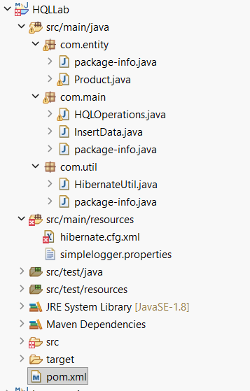

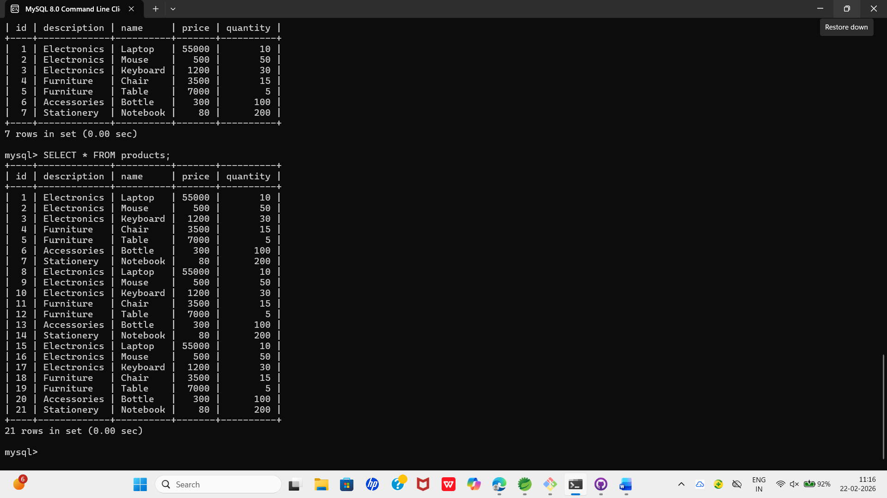
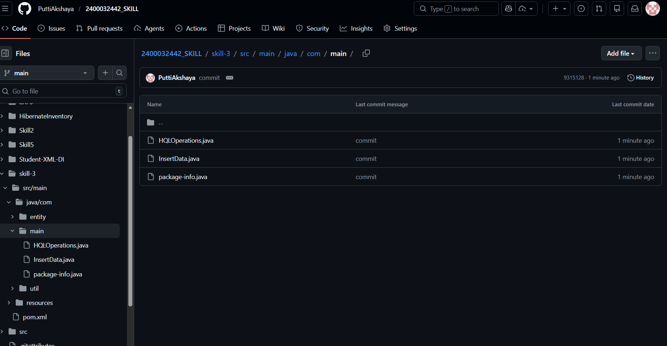

VIVA QUESTIONS:
1. What is HQL and how does it differ from SQL?
HQL (Hibernate Query Language) is an object-oriented query language used to query data from the database using entity classes and their properties, not table names.
🔹 Difference Between HQL and SQL
HQL | SQL
Works with Entity classes | Works with Database tables
Uses class names and property names | Uses table and column names
Database independent | Database dependent
Used in Hibernate | Used directly in DB
Example:
HQL
FROM Product p WHERE p.price > 1000
SQL
SELECT * FROM products WHERE price > 1000;
👉 HQL is object-oriented, SQL is relational.

2. Why do we use sorting in HQL?
Sorting is used to arrange records in a specific order.
We use the ORDER BY clause in HQL to:
- Display data in ascending or descending order
- Improve readability
- Show highest/lowest values first
Example:
FROM Product p ORDER BY p.price ASC
This sorts products by price in ascending order.

3. What is Pagination and where is it used?
Pagination means displaying data in smaller chunks instead of loading all records at once.
It is used when:
- Large amount of data exists
- Improving performance
- Showing data page by page (like websites)
Example in Hibernate:
query.setFirstResult(0);
query.setMaxResults(5);
This displays first 5 records.
4. Name any three aggregate functions supported in HQL.
HQL supports many aggregate functions:
- COUNT() → Counts number of records
- SUM() → Calculates total
- AVG() → Calculates average
- MIN() → Finds minimum value
- MAX() → Finds maximum value
Example:
SELECT COUNT(p) FROM Product p

5. What is the difference between HQL and HCQL (Hibernate Criteria Query Language)?
🔹 HQL
- Query is written as string
- Similar to SQL
- Easier for simple queries
- Example:
- FROM Product p WHERE p.price > 1000
🔹 HCQL (Criteria API)
- Query is created programmatically
- Type-safe
- No need to write query strings
- Used for dynamic queries
Example:
CriteriaBuilder cb = session.getCriteriaBuilder();
CriteriaQuery<Product> cq = cb.createQuery(Product.class);

